**Name : Mohit Manish Bhavsar**

**Roll No : 20U437**

**Div : 4**

import pandas as pd

df=pd.read_csv('https://raw.githubusercontent.com/selva86/datasets/master/BostonHousing.cs df

|  |  |  |  |  |  |  |  |  |  |  |  |  |
| --- | --- | --- | --- | --- | --- | --- | --- | --- | --- | --- | --- | --- |
|  | **crim** | **zn** | **indus** | **chas** | **nox** | **rm** | **age** | **dis** | **rad** | **tax** | **ptratio** | **b** |
| **0** | 0.00632 | 18.0 | 2.31 | 0 | 0.538 | 6.575 | 65.2 | 4.0900 | 1 | 296 | 15.3 | 396.90 |
| **1** | 0.02731 | 0.0 | 7.07 | 0 | 0.469 | 6.421 | 78.9 | 4.9671 | 2 | 242 | 17.8 | 396.90 |
| **2** | 0.02729 | 0.0 | 7.07 | 0 | 0.469 | 7.185 | 61.1 | 4.9671 | 2 | 242 | 17.8 | 392.83 |
| **3** | 0.03237 | 0.0 | 2.18 | 0 | 0.458 | 6.998 | 45.8 | 6.0622 | 3 | 222 | 18.7 | 394.63 |
| **4** | 0.06905 | 0.0 | 2.18 | 0 | 0.458 | 7.147 | 54.2 | 6.0622 | 3 | 222 | 18.7 | 396.90 |
| **...** | ... | ... | ... | ... | ... | ... | ... | ... | ... | ... | ... | ... |
| **501** | 0.06263 | 0.0 | 11.93 | 0 | 0.573 | 6.593 | 69.1 | 2.4786 | 1 | 273 | 21.0 | 391.99 |
| **502** | 0.04527 | 0.0 | 11.93 | 0 | 0.573 | 6.120 | 76.7 | 2.2875 | 1 | 273 | 21.0 | 396.90 |
| **503** | 0.06076 | 0.0 | 11.93 | 0 | 0.573 | 6.976 | 91.0 | 2.1675 | 1 | 273 | 21.0 | 396.90 |
| **504** | 0.10959 | 0.0 | 11.93 | 0 | 0.573 | 6.794 | 89.3 | 2.3889 | 1 | 273 | 21.0 | 393.45 |
| **505** | 0.04741 | 0.0 | 11.93 | 0 | 0.573 | 6.030 | 80.8 | 2.5050 | 1 | 273 | 21.0 | 396.90 |

506 rows × 14 columns

df.shape

(506, 14)

df.isna().sum()

|  |  |
| --- | --- |
| crim | 0 |
| zn | 0 |
| indus | 0 |
| chas | 0 |
| nox | 0 |
| rm | 0 |
| age | 0 |
| dis | 0 |
| rad | 0 |
| tax | 0 |
| ptratio | 0 |
| b | 0 |
| lstat | 0 |
| medv | 0 |
| dtype: | int64 |

df.info()

<class 'pandas.core.frame.DataFrame'> RangeIndex: 506 entries, 0 to 505

Data columns (total 14 columns):

# Column Non-Null Count Dtype

|  |  |  |  |  |  |  |
| --- | --- | --- | --- | --- | --- | --- |
| 0 |  | crim | 506 | non-null |  | float64 |
| 1 |  | zn | 506 | non-null |  | float64 |
| 2 |  | indus | 506 | non-null |  | float64 |
| 3 |  | chas | 506 | non-null |  | int64 |
| 4 |  | nox | 506 | non-null |  | float64 |
| 5 |  | rm | 506 | non-null |  | float64 |
| 6 |  | age | 506 | non-null |  | float64 |
| 7 |  | dis | 506 | non-null |  | float64 |
| 8 |  | rad | 506 | non-null |  | int64 |
| 9 |  | tax | 506 | non-null |  | int64 |
| 10 |  | ptratio | 506 | non-null |  | float64 |
| 11 |  | b | 506 | non-null |  | float64 |
| 12 |  | lstat | 506 | non-null |  | float64 |
| 13 |  | medv | 506 | non-null |  | float64 |

dtypes: float64(11), int64(3) memory usage: 55.5 KB

import seaborn as sns sns.heatmap(df.corr())

<matplotlib.axes._subplots.AxesSubplot at 0x7f156470a310>

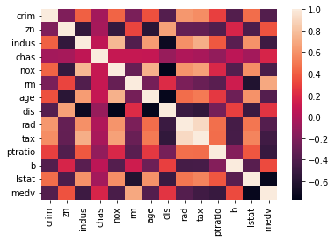

sns.heatmap(df.corr(),annot=True)

<matplotlib.axes._subplots.AxesSubplot at 0x7f155bde6650>

import matplotlib.pyplot as plt

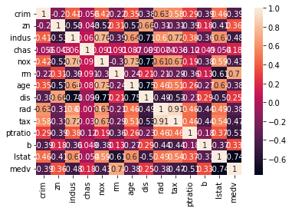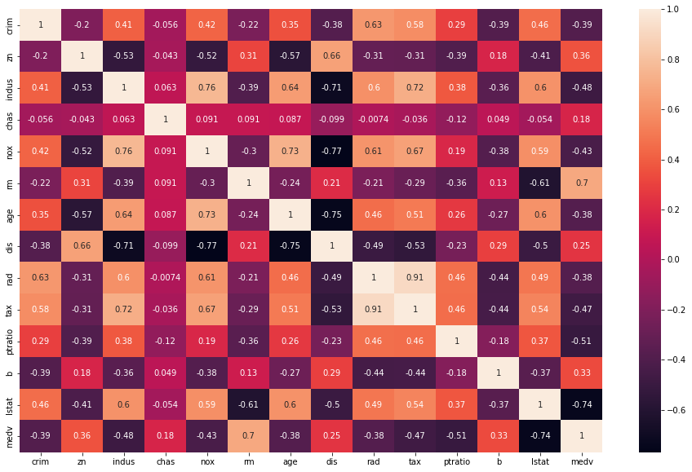

fig,ax=plt.subplots(figsize=(16,10)) sns.heatmap(df.corr(),annot=True)

<matplotlib.axes._subplots.AxesSubplot at 0x7f1559cfc750>

data=df[['rm','lstat','medv']] data

**501** 6.593 9.67 22.4

**502** 6.120 9.08 20.6

**503** 6.976 5.64 23.9

**504** 6.794 6.48 22.0

**505** 6.030 7.88 11.9

506 rows × 3 columns

|  |  |  |  |
| --- | --- | --- | --- |
|  | **rm** | **lstat** | **medv** |
| **0** | 6.575 | 4.98 | 24.0 |
| **1** | 6.421 | 9.14 | 21.6 |
| **2** | 7.185 | 4.03 | 34.7 |
| **3** | 6.998 | 2.94 | 33.4 |
| **4** | 7.147 | 5.33 | 36.2 |
| **...** | ... | ... | ... |

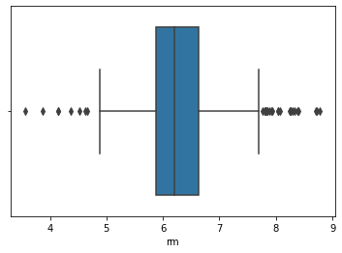

sns.boxplot(x=data['rm'])

<matplotlib.axes._subplots.AxesSubplot at 0x7f1559cfc310>

sns.boxplot(x=data['lstat'])

<matplotlib.axes._subplots.AxesSubplot at 0x7f155b7c88d0>

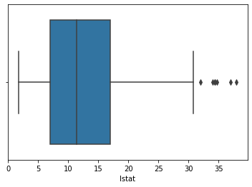

sns.scatterplot(data=data,x='rm',y='medv')

<matplotlib.axes._subplots.AxesSubplot at 0x7f1559bf0910>

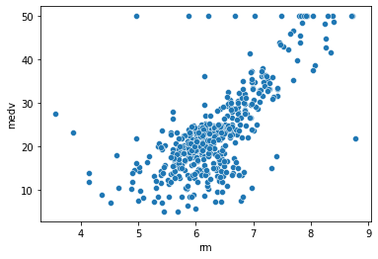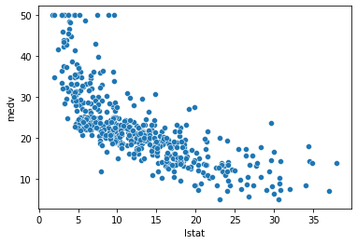

sns.scatterplot(data=data,x='lstat',y='medv')

<matplotlib.axes._subplots.AxesSubplot at 0x7f1559992b50>

x=data[['rm','lstat']] y=data['medv']

from sklearn.model_selection import train_test_split

x_train,x_test,y_train,y_test=train_test_split(x,y,test_size=0.2,random_state=42) print(x_train.shape)

print(y_train.shape) print(x_test.shape) print(y_test.shape)

(404, 2)

(404,)

(102, 2)

(102,)

print(x_train.head()) print(y_train.head())

|  |  |  |
| --- | --- | --- |
|  | rm | lstat |
| 477 | 5.304 | 24.91 |
| 15 | 5.834 | 8.47 |
| 332 | 6.031 | 7.83 |
| 423 | 6.103 | 23.29 |
| 19 | 5.727 | 11.28 |
| 477 | 12.0 |  |
| 15 | 19.9 |  |

|  |  |
| --- | --- |
| 332 | 19.4 |
| 423 | 13.4 |
| 19 | 18.2 |
| Name: | medv, dtype: float64 |

from sklearn.linear_model import LinearRegression model=LinearRegression().fit(x_train,y_train)

output=model.predict(x_test) print(output)

|  |  |  |  |  |  |
| --- | --- | --- | --- | --- | --- |
| [25.50510964 | 30.8592405 | 17.42725985 | 25.81325491 | 19.64929972 | 22.90317032 |
| 16.88571841 | 14.61917747 | 22.06066668 | 20.03326882 | 17.34725148 | 18.15555053 |
| -2.53419257 | 22.41228621 | 19.92807359 | 26.93027912 | 17.16881388 | 3.46139894 |
| 37.31795503 | 18.49325989 | 26.09287374 | 27.0359285 | 13.08646469 | 26.07395803 |
| 19.05197872 | 14.34439003 | 22.50507619 | 21.09395936 | 17.80756143 | 18.90537548 |
| 17.3189494 | 26.72355799 | 27.62430957 | 19.01752219 | 15.4809415 | 17.37191951 |
| 32.8765884 | 22.03500171 | 20.02675295 | 25.5193256 | 12.24468569 | 28.82657024 |
| 38.2438306 | 18.45117927 | 25.65604941 | 16.5588818 | 15.7090024 | 26.97797141 |
| 19.55868547 | 28.94200451 | 20.60534552 | 31.33646277 | 17.88508649 | 28.36639373 |
| 34.9844153 | 23.96269158 | 19.65312104 | 31.54864539 | 24.99070281 | 15.11477808 |
| 27.10508448 | 32.73300584 | 29.58795549 | 18.58249363 | 28.64129064 | 10.75991895 |
| 20.69510169 | 26.34948505 | 29.46875554 | 16.79445551 | 18.83002976 | 28.15270076 |
| 13.10437033 | 25.07663224 | 23.21876915 | 6.6118755 | 22.06337978 | 36.66642406 |
| 18.59482469 | 10.58587713 | 22.76126683 | 10.15832067 | 22.42113161 | 7.43849725 |
| 21.66222968 | 27.82546384 | 22.3948234 | 27.34654035 | 26.17473533 | 22.20241637 |
| 22.66415707 | 8.2959451 | 22.97660538 | 20.3782187 | 11.11664989 | 23.94904829 |
| 24.10216559 | -0.28767556 | 20.05222704 | 19.11836595 | 20.89746052 | 24.85789666] |

print(y_test)

|  |  |  |  |
| --- | --- | --- | --- |
| 173 | 23.6 |  | |
| 274 | 32.4 |  |  |
| 491 | 13.6 |  |  |
| 72 | 22.8 |  |  |
| 452  412 | 16.1  ... 17.9 |  |  |
| 436 | 9.6 |  |  |
| 411 | 17.2 |  |  |
| 86 | 22.5 |  |  |
| 75  Name: | 21.4  medv, | Length: 102, | dtype: float64 |

from sklearn.metrics import mean_absolute_error print('MAE:',mean_absolute_error(y_test,output)) print("Model Score:",model.score(x_test,y_test))

MAE: 3.8987597213823584

Model Score: 0.5739577415025858

 